Ring a Bell for Rosies™
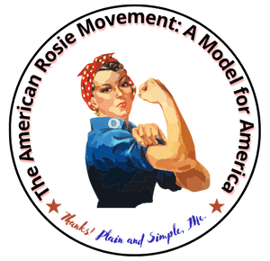

THANKS! Plain and Simple, Inc., with the American Rosie Movement
Pulling together for Freedom, the Rosie Way

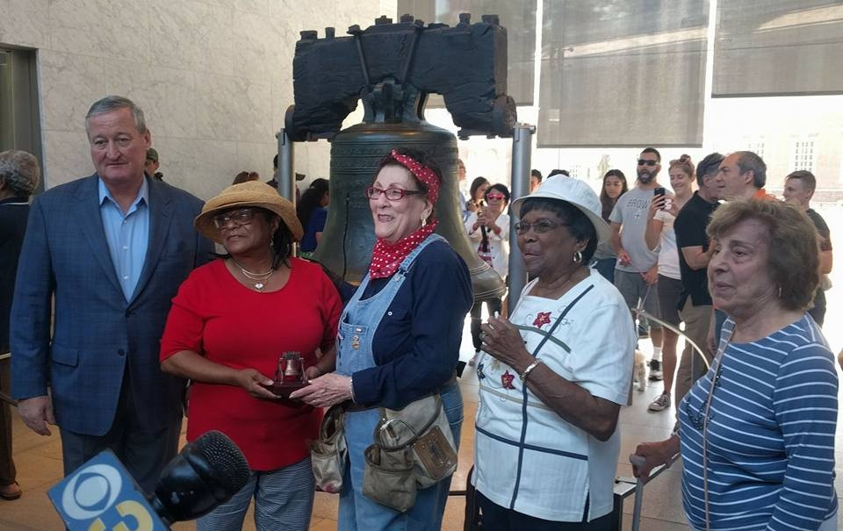
Labor Day
Date
12:30 to 1:30 p.m.
Address

Don’t be late!
Bring your own Bell!

Ring a Bell for Rosies:
Please arrive by 12:15. At 1:00 p.m. you and others will ring a bell for 15 seconds to honor Rosies and their excellent work to pull together for freedom. Take plenty of photos - this is a historic event.
12:30 Welcoming
12:33 Meaning of This Day
12:36 Acknowledge special guests 12:40 Prayer and Pledge of Allegiance
12:45 Brief Introduction of Rosie(s) present 12:59 One minute of silence
1:00 Bells will be rung for 15 seconds precisely 1:01
1:11
1:28
Special “Thanks!” to Our Volunteers!

Americans like you to help launch the American Rosie Movement.
Together we will work to guide Americans to pull together by following the Rosie Legacy™:
To pull together to do highest-quality work, so that we use our freedom to preserve our freedom. .

Contact:
or
Alternate: American Rosie movement, (304) 545-9818, managingbetter@earthlink.net, www.AmericanRosieMovement.org

